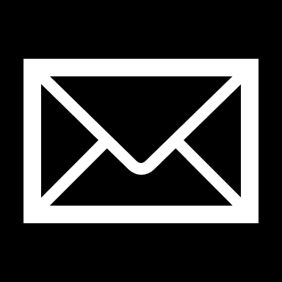

**P E R S O N A L P R O F I L E**

•••• Project Management

•••• Problem-Solving

•••• Willingness to Learn

•••• Time Management

•••• Leadership

•••• Decision Making

**S K I L L S S U M M A R Y**

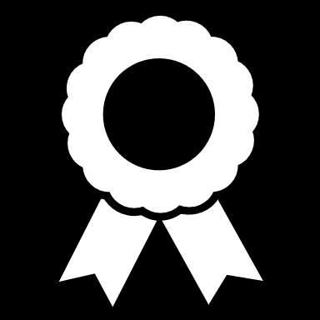

IRB Human Research

Google Analytics

Bloomberg

**C E R T I F I C A T I O N S**

Member of Mu Kappa Tau, National Marketing Honors Society

Loyola Scholarship recipient. Given with a minimum GPA of 3.2 or higher

President of the Praise and Worship club (2020- 2021)

Class of 2022 Senator

(2018-2019)

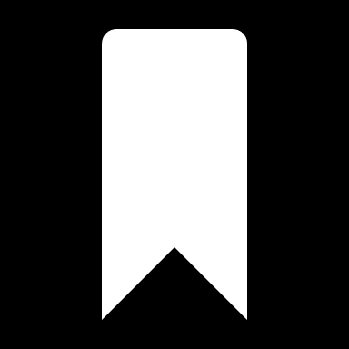

**A C T I V I T I E S & H O N O R S**

**C O N T A C T M E A T**

900 Mulberry Street, Scranton, PA 18510

email@gmail.com

555-555-5555

www.linkedin.com/in

I am a goal-oriented marketing major with robust problem-solving skills, an eye for detail, and a passion for connecting individuals through media.

**Marketing Communication Intern**

The University of Scranton | August 2020 – Present

* Responsible for establishing a strong brand identity for The University of Scranton
* Plan and schedule social media posts across various platforms
* Analyze, improve, and innovate The University of Scranton's brand based on statistical analysis

**Marketing and Social Media Intern**

South Jersey News Today (SNJ Today) | May 2020 - August 2020

* Assisted radio personnel while learning the different aspects of radio broadcasting
* Addressed radio talk show hosts and listeners during morning public live broadcasting appearances
* Coordinated local branding events to engage with new and potential listeners
* Developed and managed social media campaigns and platforms

**Marketing Intern**

The Greater Scranton Chamber of Commerce | September 2019 - February 2020

* Produced videos and web content for social media platforms
* Researched and applied best practices for The Chamber’s social media presence, including Facebook, Instagram, LinkedIn, and other sites
* Utilized video editing programs like Adobe Premiere and Toonly to better advertise and promote The Chamber

**C A R E E R E X P E R I E N C E**

**The University of Scranton – Kania School of Management**

Bachelor of Science in Marketing | Minor in Management Anticipated Graduated May 2022

Over all GPA: 3.57/4.00

**E D U C A T I O N**

**L E A D E R S H I P E X P E R I E N C E**

**Account Executive**

The National Student Advertising Competition (NSAC) | August 2020 - March 2021

* Managed client project, planned and regulated campaign until project completion
* Implemented strategy and achieved team goals, solved problems, and developed strong relationships between team members
* Held prominent role in Creative and Media departments. Constructed media budget, designed commercials and billboards using Adobe Premiere and Adobe Photoshop

**Executive Treasurer**

The University of Scranton Student Government | May 2019 - May 2020

* Approved Student Government expenditures, provided direction on financial projections and articulated spending parameters
* Oversaw budgeting process, including club allocation meetings with the aid of the Appropriations Committee
* Met with club leaders regularly, including semesterly meetings regarding budgeting processes and club responsibilities related to use of student activity fee funds

**Enrollment Management & External Affairs Committee Student Liaison**

The University of Scranton Board of Trustees | May 2019 - May 2020

* Provided commentary and “student perspective” to critical functions at the University including:
  + Admissions, Community and Government Relations, Small Business Development Center, Marketing, Branding, Printing and Mailing Services, Media Relations, and Crisis Communication

**FIRST NAME LAST NAME**